Nama: Hanifan Nurul Haq 6706184096
M. Faishal Hasbi 6706184091
Kelas: D3IF-42-02

Linux Command to show Threads

1. PS => to display processes for the current shell

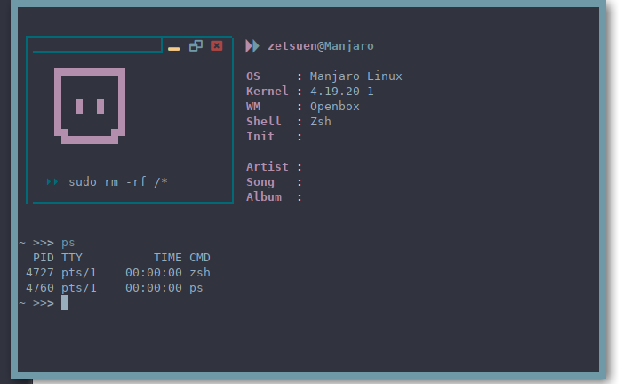

2. htop =>to display data of various system processes and their resource consumption in a human-readable, color-coded, easy-to-use format
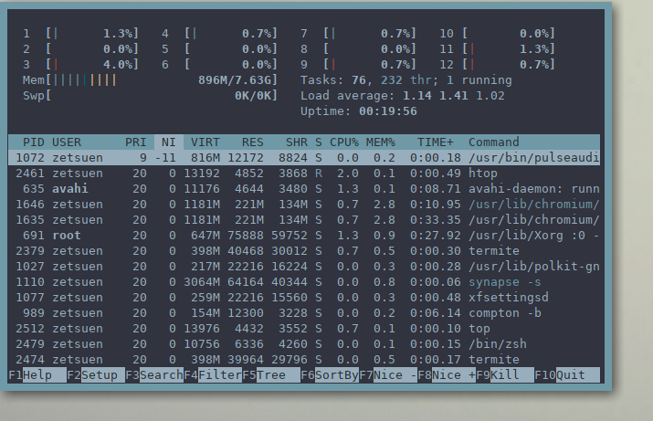

3. top => Display and update information about the top CPU processes
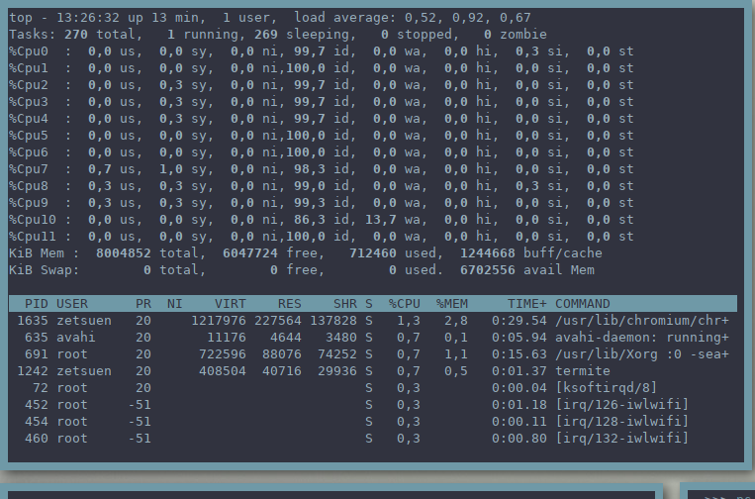
4. ps -A =>Display every active process on a Linux system in generic (Unix/Linux) format.
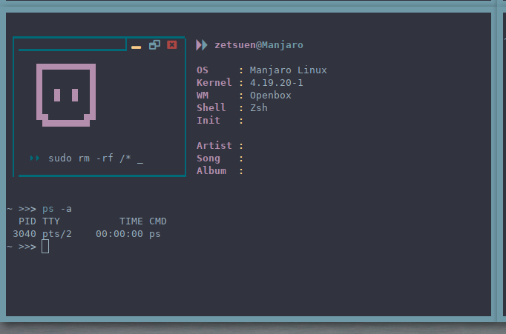
5. ps au => Display all processes in BSD format.
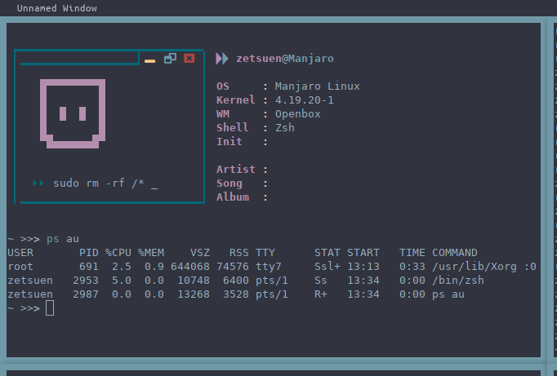
6. ps -eF => to display process based on flag
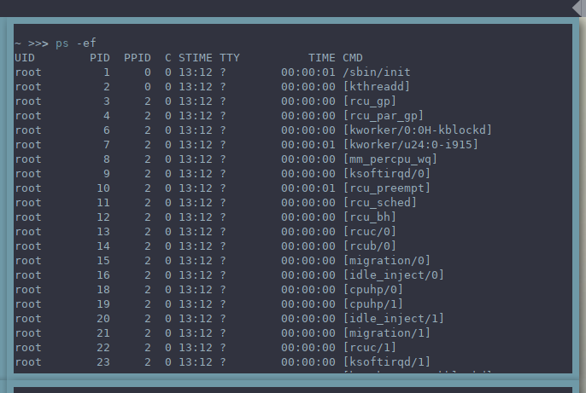
7. ps -x =>to display processes owned by user
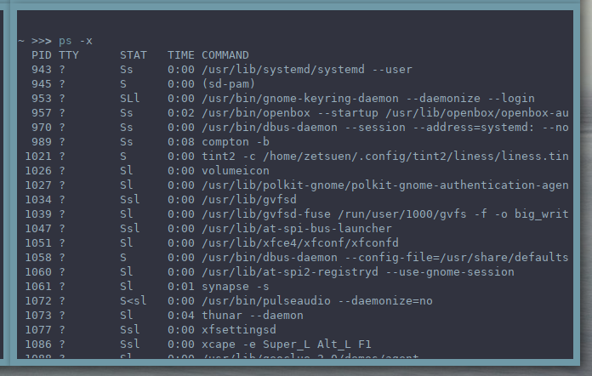
8. ps -fU =>to display processes by real user ID(RUID) or name.
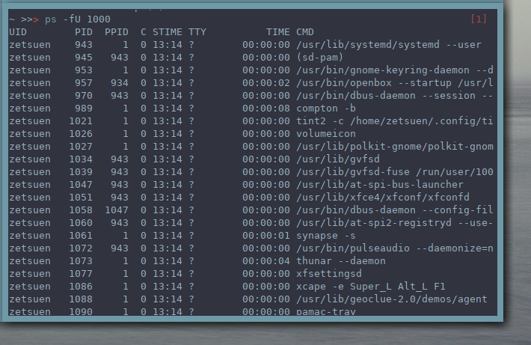
9. ps -U root -u root => to display every process running with root privileges.
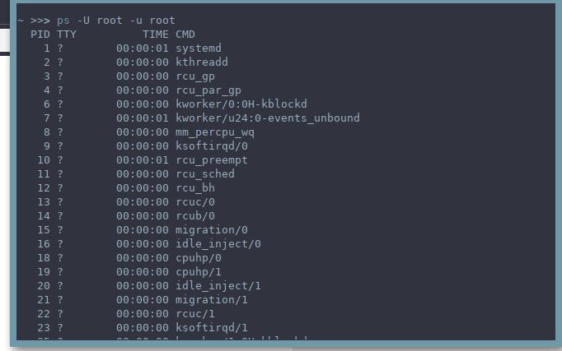
10. ps -e –forest => to display proces tree that show how processes on the system linked each other.
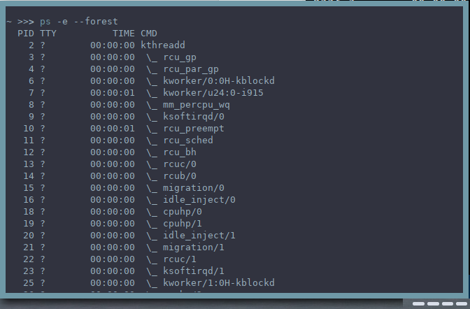
11. ps -fL =>to print all threads of a process.
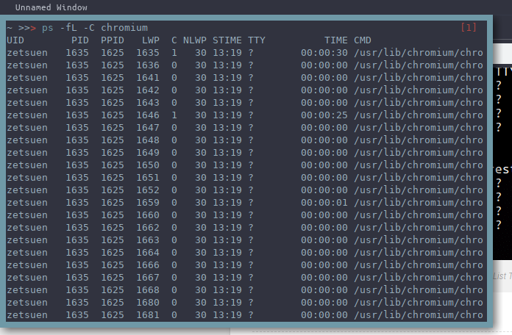
12. ps -eo => to display pid, ppid, username and command of a process.
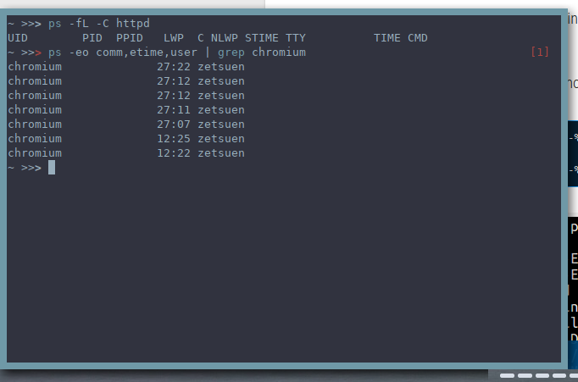
13.pstree => to show processes tree.
